

**Assignment No: LAB-05**

Submitted by:

Name : Haseeb Ullah

ID: F20232661009

Section: V21

Submitted to:

Name: Sir Riaz Ahmad

**Topic: If else-if and switch**

**Address:** C-II Block C 2 Phase 1 Johar Town, Lahore, Punjab 54770.

University of Management & Technology.

**EXAMPLES of Lab**

**Example 5.1**: Demonstration of if statement. You want to display a congratulatory message in case a student has passed a course. The passing marks are 50%.

|  |
| --- |
| #include <iostream>  using namespace std;  int main()  {      int marks, total, percent=0;      cout << "Enter the marks obtained in PF: " ;      cin >> marks;      cout<<"Enter the total marks: ";      cin >> total;      percent = (marks*100)/total;      if (percent >= 50)          cout << "Congragulations you have passed the subject" << endl;          cout << "THANK YOU." << endl;      return 0;  } |

Output

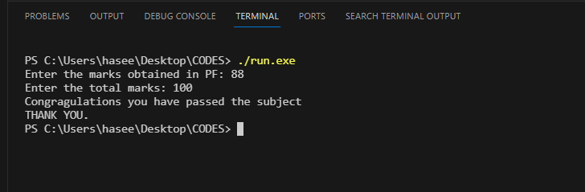

**Example 5.2:** Demonstration of if statement.

|  |
| --- |
| #include<iostream>  using namespace std;  int main()  {      int marks,total,percent=0;      cout << "Enter the marks obtained in PF:";      cin >> marks;      cout << "Enter the total marks:";      cin >> total;      percent = ( marks * 100) / total;      if (percent >= 50){          cout<<"Congragulations you have passed the subject"<<endl;          cout<<"WELL DONE!"<<endl;      }      cout<<"THANK YOU."<<endl;  return 0;  } |

Output

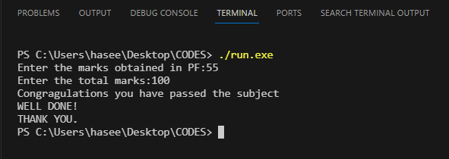

**Example 5.3:** Demonstration of if-else statement.

|  |
| --- |
| #include<iostream>  using namespace std;  int main()  {      int marks,total,percent=0;      cout << "Enter the marks obtained in PF:";      cin >> marks;      cout << "Enter the total marks:";      cin >> total;      percent = ( marks * 100) / total;      if (percent >= 50){          cout<<"Congragulations you have passed the subject"<<endl;          cout<<"WELL DONE!"<<endl;      }      else{          cout<<"Sorry! You are failed."<<endl;      }      cout<<"THANK YOU."<<endl;  return 0;  } |

Output

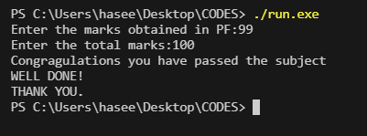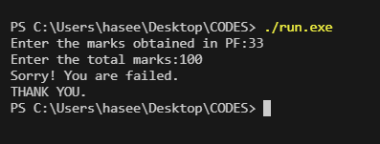

**Example 5.4:** Input a number from user and display whether it is a positive or negative number

|  |
| --- |
| #include<iostream>  using namespace std;  int main(){      int input;      cout << "Enter a number:";      cin >> input;      if ( input > 0)      cout<<"A positive number was entered."<<endl;      cout<<"Thank You."<<endl;  return 0;  } |

Output

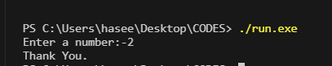

**Example 5.5:** Input five values from the user and display the maximum number from the list.

|  |
| --- |
| #include<iostream>  using namespace std;  int main(){      int a,b,c,d,e;      cout << "enter 1st number: ";      cin >> a;      cout << "enter 2nd number: ";      cin >> b;      cout << "enter 3rd number: ";      cin >> c;      cout << "enter 4th number: ";      cin >> d;      cout << "enter 5th number: ";      cin >> e;      if(a>b && a>c && a>d && a>e)          cout<<a<<" is the greatest"<<endl;      else if(b>a && b>c && b>d && b>e)          cout<<b<<" is the greatest"<<endl;      else if(c>a && c>b && c>d && c>e)          cout<<c<<" is the greatest"<<endl;      else if(d>a && d>b && d>c && d>e)          cout<<d<<" is the greatest"<<endl;      else if(e>a && e>b && e>c && e>d)          cout<<e<<" is the greatest"<<endl;  return 0;  } |

Output

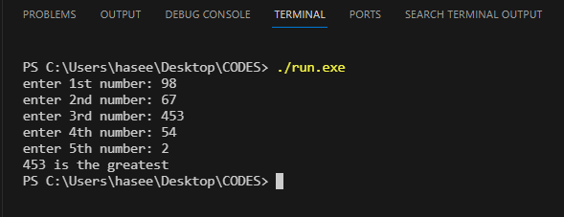

**Example 5.6:** Prompt the user to enter the salary and grade of an employee. If the employee has a grade greater than 15 then add 50% bonus to the employee’s salary. Otherwise if the employee’s grade is less than 15 then add 25% bonus to the employee’s salary.

|  |
| --- |
| #include <iostream>  using namespace std;  int main(){      double salary,grade;      cout << "Enter the salary of the employee: ";      cin >> salary;      cout << endl << "Enter the grade of the employee: ";      cin >> grade;      if (grade > 15){          salary = salary + (salary * .50);          cout << "Salary with 50% bounes\n" << salary;          }          else if(grade >= 10 && grade <= 15 ){              salary = salary + (salary * .25);              cout << "Salary with 25% bounes\n" << salary;          }          else {              cout << "Salary with 0% bonues" << salary;          }        return 0;  } |

Output

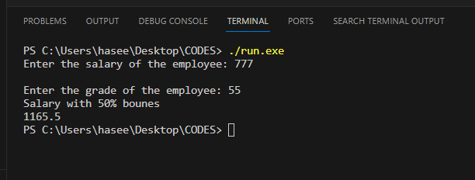

**Using Switch Method:**

|  |
| --- |
| #include <iostream>  using namespace std;  int main(){      double salary;      char grade;      cout << "Enter the salary of the employee:\n ";      cin >> salary;      cout << "Enter the grade from A-B:\n ";      cout << "if grade is > 15 then use A \n";      cout << "if grade is < 15 then use B \n";      cout << "Grade: ";      cin >> grade;      switch (grade)      {      case 'A' :               salary = salary + (salary * .50);          cout << "Salary with 50% bounes\n" << salary;          break;      case 'B':              salary = salary + (salary * .25);              cout << "Salary with 25% bounes\n" << salary;      default:              cout << "valid grade";          break;      }      return 0;  } |

Output

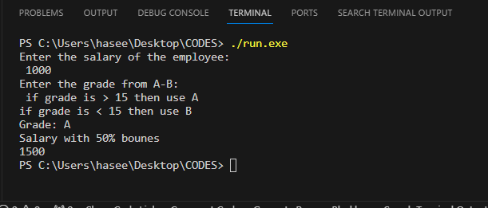

**Example 5.7: Demonstration of switch statement.**

|  |
| --- |
| #include<iostream>  using namespace std;  int main() {  char grade;  cout<<"Enter a grade in capital letters From A-F :  ";  cin>>grade;  switch(grade)  {  case 'A':          cout<<"You have scored 90% marks."<<endl;           break;  case 'B':          cout<<"You have scored 80% marks."<<endl;           break;  case 'C':          cout<<"You have scored 75% marks."<<endl;           break;  case 'D':          cout<<"You have scored 70% marks."<<endl;           break;  case 'E':          cout<<"You have scored 65% marks."<<endl;           break;  case 'F':          cout<<"You have scored 23% marks."<<endl;           break;    default:           cout<<"You have not Enter valid Grade"<<endl;           break;  }  return 0;  } |

Output

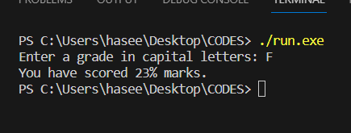

**MY WORK**

|  |
| --- |
| #include <iostream>  using namespace std;  int main()  {      int marks,total,percent=0;      cout <<"Enter the marks obtained in PF:";      cin >>marks;      cout<<"Enter the total marks:";      cin>>total;      percent = (marks*100)/total;      if (percent > 90 && percent <= 100){          cout << "first position" ;      }      else if(percent > 85 && percent <= 90) {          cout << "second position" ;      }      else if(percent > 75 && percent <=85 ){          cout << "third position" ;      }      else if(percent > 33 && percent <= 75){          cout << " Pass" ;      }      else{          cout << "fail" ;      }      cout << "THANK YOU."<<endl;    return 0;  } |

Output

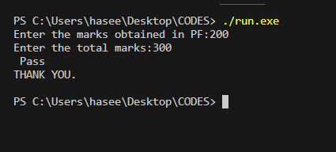

**LAB WORK**

**Exercise 5.1:** Prompt the user to input 5 values and display the minimum number amongst them.

|  |
| --- |
| #include<iostream>  using namespace std;  int main(){      int a,b,c,d,e;      cout<<"enter 1st number: ";      cin>>a;      cout<<"enter 2nd number: ";      cin>>b;      cout<<"enter 3rd number: ";      cin>>c;      cout<<"enter 4th number: ";      cin>>d;      cout<<"enter 5th number: ";      cin>>e;      if(a<b && a<c && a<d && a<e){          cout<<a<<" is the smalest"<<endl;      }      else if(b<a && b<c && b<d && b<e){          cout<<b<<" is the smalest"<<endl;      }      else if(c<a && c<b && c<d && c<e)      {          cout<<c<<" is the smalest"<<endl;      }      else if(d<a && d<b && d<c && d<e){          cout<<d<<" is the smalest"<<endl;      }      else if(e<a && e<b && e<c && e<d){          cout<<e<<" is the smalest"<<endl;      }  return 0;  } |

Output

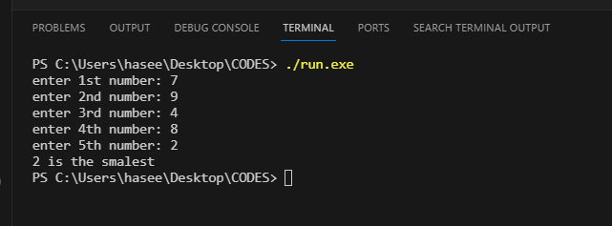

**Exercise 5.2:** Input five values through the user and display the number of positives,

the number of negatives,

the number of zeros amongst the 5 values.

|  |
| --- |
| // variables a b c d e and positive, negative, and zeros.  // if a>0 then  in positive variable incriemaent 1 if a<0 then in negative variable incriment  //and a==0 zero varible inciement  //in the end execution will be num +, num -, num 0;  #include <iostream>  using namespace std;  int main() {        double a = 0,b = 0,c = 0,d = 0,e = 0;      int positive = 0, negative = 0, zero = 0;      cout << "Enter first value: ";      cin >> a;      if (a>0){          positive++;      }      else if (a<0){          negative++;      }      else if(a==0){          zero++;      }      cout << "Enter second value: ";      cin >> b;      if (b>0){          positive++;      }      else if (b<0){          negative++;      }      else if(b==0){          zero++;      }      cout << "Enter thrid value: ";      cin >> c;      if (c>0){          positive++;      }      else if (c<0){          negative++;      }      else if(c==0){          zero++;      }      cout << "Enter fourth value: ";      cin >> d;      if (d>0){          positive++;      }      else if (d<0){          negative++;      }      else if(d==0){          zero++;      }      cout << "Enter fifth value: ";      cin >> e;      if (e>0){          positive++;      }      else if (e<0){          negative++;      }      else if(e==0){          zero++;      }      cout << "The total of POSITIVES number are: " << positive << endl;      cout << "The total of NEGATIVES number are: " << negative << endl;      cout << "The total of ZEROS number are: " << zero << endl;      return 0;  } |

**Output**

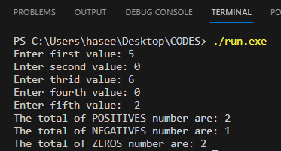

**Exercise 5.3:** Prompt the user to input a character and display whether it is a vowel or consonant using

*switch* statement.

|  |
| --- |
| #include<iostream>  using namespace std;  int main() {      char vowel;      cout<<"Enter a Word :  ";      cin>>vowel;  switch(vowel)  {  case 'a':          cout<<"It is a vowel."<<endl;           break;  case 'e':          cout<<"It is a vowel."<<endl;           break;  case 'i':          cout<<"It is a vowel."<<endl;           break;  case 'o':          cout<<"It is a vowel."<<endl;           break;  case 'u':          cout<<"It is a vowel."<<endl;           break;    default:           cout<<"It is not vowel."<<endl;           break;  }  return 0;  } |

Output

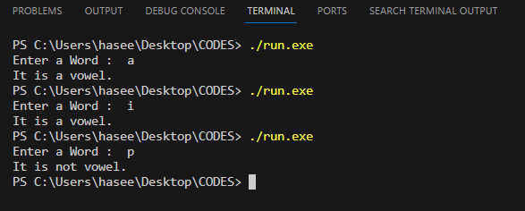

**HOME TASK**

* + 1. Ask the user to enter marks obtained in a course and the total marks of the course. Then display a menu

Press 1 to calculate percentage. Press 2 to display grade.

If the user presses 1 then percentage should be displayed and if the user presses 2 the grade against the marks should be displayed. (Hint: use switch statement for menu selection and else if to display the grade).

|  |
| --- |
| #include <iostream>  using namespace std;  int main(){      int menu;      double marks, total, percentage = 0;      cout << "Enter the obtained marks: ";      cin >> marks;      cout << "Enter the total marks: ";      cin >> total;      cout << "if you want percentage than enter 1\n";      cout << "if you want grade of the obtain marks then enter 2\n";      cin >> menu;      percentage = (marks / total) * 100;      switch (menu)      {      case (1):          cout << "The total marks is: " << percentage;          break;        case (2):          if(percentage > 90)          cout << "Grade A";          else if(percentage > 85 && percentage <= 90)          cout << "Grade B";          else if(percentage > 75 && percentage <= 85)          cout << "Grade C";          else if(percentage > 33 && percentage <= 75)          cout << "Grade D";          else if(percentage > 0 && percentage <= 33)          cout << "Grade F";          break;        default:            cout << "\nEnter valid choice in the menu";          break;      }      return 0;  } |

Output

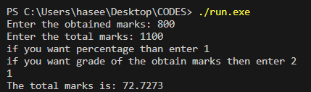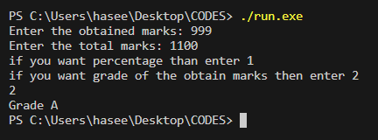

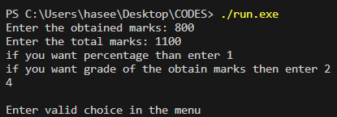

* + 1. Prompt the user to enter 3 values. For any equal values, the program should display the numbers that are equal. (For example user input 34,6,34 the program should display the message that the 1st and 3rd values are equal).

|  |
| --- |
| #include <iostream>  using namespace std;  int main(){      int value1, value2, value3;      cout << "Enter 1st value: ";      cin >> value1;      cout << "Enter 2nd value: ";      cin >> value2;      cout << "Enter 3rd value: ";      cin >> value3;      if(value1 == value2)          cout << "1st and 2nd values are equal: " << value1 << " and " << value2 << endl;      else if(value1 == value3)          cout << "1st and 3rd values are equal: " << value1 << " and " << value3 << endl;      else if(value2 == value3)          cout << "2nd and 3rd values are equal: " << value2 << " and " << value3 << endl;      else {          cout << "Non-value are equal";          }      return 0;  } |

**Output**

